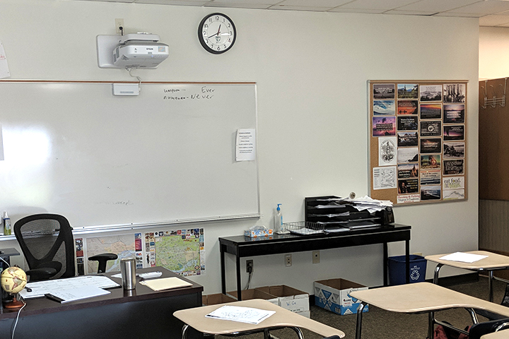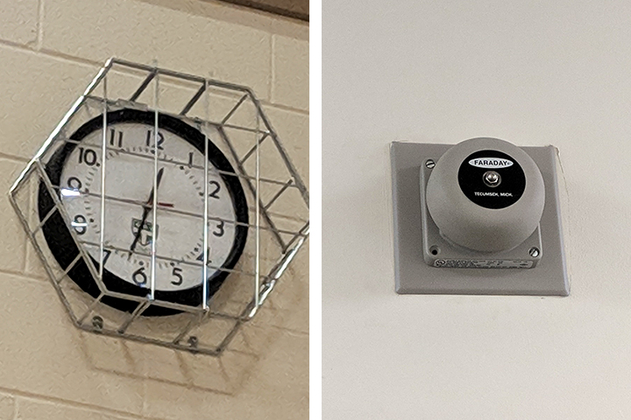

•••

## Trinity Episcopal School - Richmond, Virginia

**Trinity Episcopal School Quick Facts:**

**American Time solution:** SiteSync IQ Wireless Clock System, Wireless Bells, and Wire Guards

**Campus size:** Six buildings across 39 acres

**Enrollment:** +500

Trinity Episcopal School is an independent, co-educational school for grades 8 through 12 and is the Richmond area’s first school authorized to offer the International Baccalaureate Program. Trinity’s mission is to challenge its students to discover their paths, develop their talents and strengthen their character within a dynamic community.

**Challenge**

For a decade, Trinity has relied on American Time to help solve its challenges with synchronized time and bell schedules. The original campus buildings featured hard-wired clock systems, but the school was quickly expanding and extending wired clocks to the new facilities was cost-prohibitive. Instead, the school and teachers bought clocks from an office-supply store to keep the time in each classroom, even though the clocks weren’t synchronized with each other and had to be adjusted twice each year for daylight saving time (DST) changes.

In addition, Trinity runs a variety of bell schedules that depends on the day of the week, weather conditions, late starts, half-days, graduations, teacher workshop days, and so on. With its old system, Trinity was faced with a complicated control panel that inadvertently caused users to ring bells at the wrong times, causing confusion in the classrooms. Eventually, the main controller for the existing system started to fail and staff had to hand-ring bells to signal the beginning and end of classes.

When Trinity searched for a clock technology system that could help solve these problems and others, it was thrilled to find American Time solutions. Specifically, the [SiteSync IQ Wireless system](https://www.american-time.com/products-by-family/complete-clock-systems/sitesync-iq-wireless-system) with wireless bells and/or buzzer clocks can replace an old clock system or integrate with an existing one. It was the flexibility that Trinity needed to keep expanding its campus while keeping everyone running on time.

**Solutions**

Throughout the years, Trinity has relied on a variety of American Time solutions to address its clock and bell schedule needs.

The American Time SiteSync IQ system seamlessly integrates with the school’s new wireless clock system and existing wired bells. Trinity has also chosen [wire guards](https://www.wireguards.com/) to protect many of its investments, especially in high-traffic areas like its 50,000 square foot athletic center.

With one main controller in a centrally located building and an antenna on the campus’s tallest building, Trinity has the power it needs to reach every corner of its 39-acre campus. “The controller broadcasts to our largest building that’s 60,000 square feet and solid cinderblock,” said Jason Bavaro of facilities support at Trinity. “Even cell phone signals have trouble working in there! But we’ve never had a problem with our clocks and we don’t even need a booster.”

**Results**

Because SiteSync IQ works with legacy systems or new ones, wired clocks or wireless ones, Trinity has been able to expand synchronized time at its own pace as new buildings are constructed or as old clocks fail. “I just swap out the old clock with a new wireless one, and when I come back to the room the clock is synchronized and running,” said Jose Santiago, technology support at Trinity Episcopal School. “Plus, they update for daylight saving time automatically, so I don’t have to run around making sure the clocks are synchronized. That saves me a lot of time.”

Santiago went on to explain that bell ringing is crucial at the school, so the wireless bell system drives each day. “It was a big breakthrough when we hardwired the existing bells with the SiteSync wireless system,” he explained. “All of the clocks and bells are now controlled with SiteSync IQ and it’s not a problem anymore.” In the newer buildings in which wired bells weren’t installed, Trinity installed clocks with built-in buzzers or [wireless bells](https://www.american-time.com/products-by-family/complete-clock-systems/sitesync-iq-wireless-system/wireless-clock-system-accessories/wireless-indoor-bells) depending on the need.

The school has a complex scheme of 16 different bell schedules that can be controlled remotely with American Time technology. “I like the flexibility of opening up the menu of different circuits and assigning different schedules to each circuit. That automation is really helpful,” said Santiago. “One time I was on a cruise in Antarctica and I had to change the school’s bell schedule that day. I just logged in and did it!” He went on to note that the wireless bell is “plenty loud” for even the noisiest areas of the school, including a large classroom that regularly has more than 75 kids and teachers in it.

The reliability of the clocks and SiteSync IQ is very important to Trinity. “Several years go by before I have to replace the four-pack of batteries in each clock,” said Bavaro. “For our clocks that have the new [six-pack of batteries](https://www.american-time.com/products-by-family/clock-parts-and-repairs/clock-parts-accessories/battery-booster-pack/) in them, I don’t even know how long those will last. Maybe I’ll get to retire before we have to replace them!”

The school [logo on each clock](https://www.american-time.com/resources/customize-your-clocks) gives classrooms a more professional and clean look. “The teachers were furnishing their own clocks, but now we all have one look,” said Santiago. “We also like that the numbers on the clocks are big, so you can read them from far away.”

Both Bavaro and Santiago say that quality customer service has kept them coming back to American Time over the years. “Your tech support is excellent,” they agreed. “Your solutions are very expandable and customer friendly to use, and if we ever have a problem or question, we call your team and they help us figure it out.”