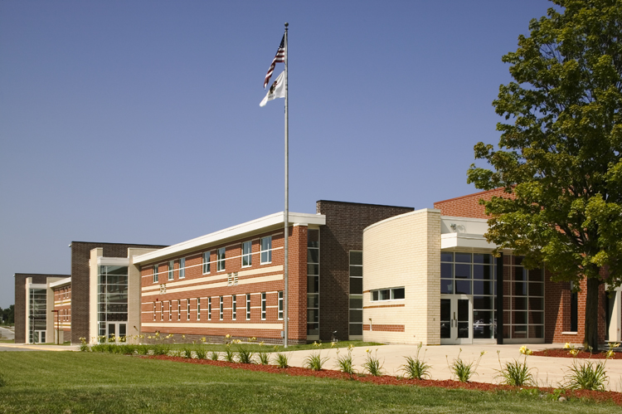

## School reduces classroom disruptions and expensive repairs with wireless time system and full array of clock options

**McHenry Quick Facts**

**Type of project:** Replacement of wired clock system

**American Time solution:** SiteSync IQ wireless clock system

**Enrollment:** +2,300 students across two campuses

McHenry Community High School (MCHS) provides a comprehensive education to students from a 40-square mile area, including the communities of Wonder Lake, Lakemoor, Holiday Hills, Bull Valley, McCullom Lake, Island Lake and McHenry. The East Campus and West Campus, located about one mile apart, serve more than 2,300 students.

**Challenge**

Both MCHS campuses had synchronized time systems, but neither functioned properly. Clocks fell out of sync, they didn’t update for daylight saving time twice per year, and they broke frequently. Teachers and students often relied on their mobile phones to determine the time, and some teachers brought in their own battery-powered clocks for the classroom. This led to students being released too early from classes, or even hundreds of students leaving the cafeteria too early and subsequently causing disruptions in classroom time.

“We were constantly messing with the master controller to try to get the times right, and we were buying a lot of parts to fix the clocks. I was probably fixing four or five a month, with no end in sight,” explained Kevin Weisenberger, facilities manager at MCHS. “All of that led to the decision to replace the entire clock system.”

Each campus had an old, wired master clock system that made it difficult to schedule the clocks with the schools’ bell systems.

**Solutions**

MCHS looked at several vendors when researching synchronized clock systems. Having purchased clock parts from American Time before, Weisenberger knew the team and trusted the people and the technology. “American Time presents the information very clearly and they had lots of good ideas about the types of clocks that would solve our problems,” said Weisenberger. “For example, they recommended digital and countdown clocks, and we’ve really come to embrace those.”

MCHS purchased a 10-watt and 25-watt wireless remote transmitter, along with a SiteSync IQ wireless clock system to replace the old master clock and bell systems at the West and East Campuses. The school chose a large assortment of wired clocks, wireless analog clocks, wireless battery clocks and digital clocks, including some that were configured to count down the time between classes.

**Results**

With American Time’s SiteSync IQ, MCHS now has a synchronized system in which all clocks display the same, precise time, and bells are completely in sync. “It’s all consistent!” said Weisenberger. “It’s very important to have our students synchronized during classes and in between classes, and now everything is exact. It’s also moving me away from doing so many clock repairs, and the teachers don’t have to constantly put in work orders for new clocks.”

The countdown clocks let students know exactly how much time – down to the second – they have to get to the next classroom. The large numbers on the clocks are visible even down the schools’ long hallways. “That’s really cut down on stragglers,” said Weisenberger. “And it’s one less disruption to the students’ education.”

The free option to include the MCHS logo on the analog clocks was a value-added option to MCHS. “Our logo on all of the clocks seems like a simple thing, but it’s really a nice statement of school spirit and pride,” noted Weisenberger.

American Time works hard to ensure its systems are easy to install – even by the customer – and MCHS was no exception. “We did it all ourselves,” said Weisenberger. “The American Time team was very helpful if we had any questions, but it was pretty much turnkey. Any time you can work with a system and with people like that – that’s awesome.”