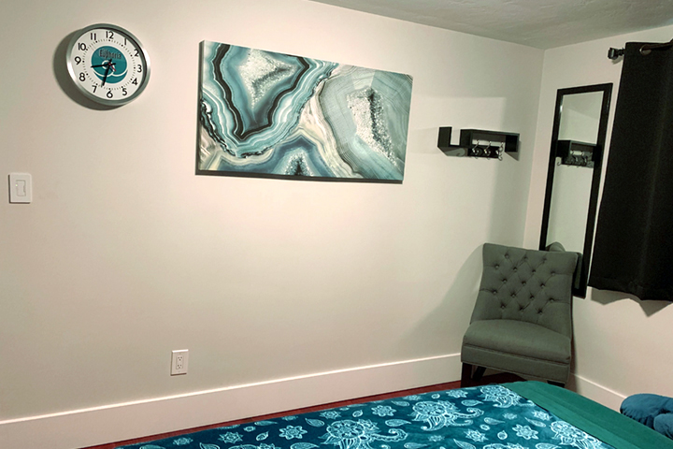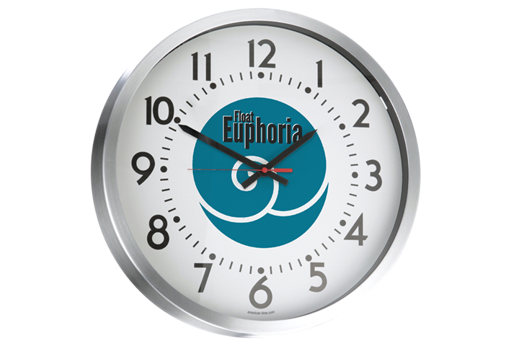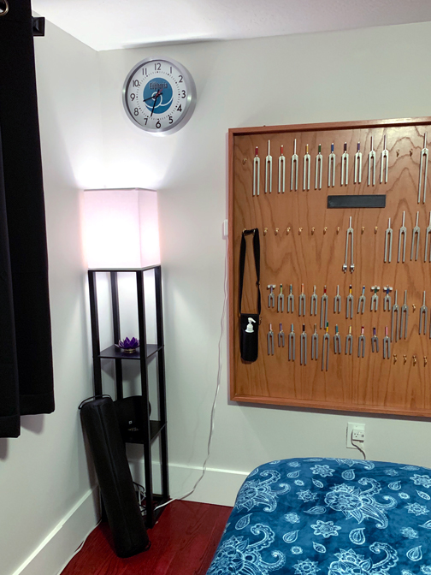

•••

## Massage and Flotation Therapy Service uses Wi-Fi Clocks

**Float Euphoria Quick Facts**

**Industry:** Health/Well-Being

**American Time solution:** Wi-Fi Network Clocks

[**Float Euphoria’s**](https://www.floateuphoria.com/) mission is to provide a warm, loving place of peace and relaxation where clients may experience a variety of healing modalities. Through professional massage, flotation therapy and sensory REST, Float Euphoria aims to give individuals relief from stress, anxiety, and physical ailments that result from living in such a fast-paced world.

**Challenge**

Managing both a massage and flotation service requires adhering to strict standards for maintenance, cleaning and time management to keep appointments on track. “We run a float every two hours,” explained Ryan Wright, owner, Float Euphoria. “In between appointment times, the tanks have to be cleaned and polished, so we’re on a very tight schedule.”

Couples’ massages and flotations are a popular service as well, but require synchronizing the massage of each individual so they can experience a flotation concurrently. “Our massage therapists need to finish up at the same time so the couple can experience the flotation pod together. Being a few minutes off is a challenge,” said Wright. “I bought some clocks on Amazon so our therapists could synchronize the massages and we could keep accurate timing for our flotation sessions. The clocks were supposed to be accurate, but none of them were.”

Wright and his team found that the clocks would drift at different rates, causing some appointments to run longer or shorter than others. Wright found synchronized digital clocks for purchase, but the look of digital didn’t fit Float Euphoria’s brand. “Digital would take away from the ambiance,” he said. “I wanted something analog that would blend in.”

**Solution**

Wright searched the internet and found what he was looking for at American Time. “All of the other vendors had clocks that were geared for huge institutions where I’d have to invest in a master clock or buy 100 clocks. They weren’t interested in working with a small business like mine. American Time had exactly what I needed. I could order just a few clocks and the pricing was right.”

Wright chose American Time’s Wi-Fi Network clocks customized with Float Euphoria’s name and logo. Wi-Fi clocks are a fast and affordable way to get the same, precise time in any-sized business: there’s no need to purchase a master controller, wires, license fees or cables. Just a typical wireless router will keep all of the clocks in sync and automatically update for daylight saving time.

Although Wright was excited about the technology and affordability of the clocks, he wanted to make sure they would be quiet and not distract from a client’s service. “American Time sent me a clock to try out so I could assess the noise, and I thought that was really cool of them to do,” said Wright. “I found that unless I put my ear up to the clock, I couldn’t hear any ticking and they weren’t a distraction for our clients or therapists. Plus the clock easily synched with my NTP server to show the right time.”

**Results**

American Time Wi-Fi clocks have been accurate down to the second, which allows Float Euphoria’s appointments to stay on time and provides a better experience for clients and employees alike. “The therapists get the clients out at the exact right time. They’ll actually walk out of the room at the exact same time!” said Wright.

Wright chose to configure the Wi-Fi clocks himself, which was a simple process. “The instructions are really straightforward and it worked great. I actually expected some sort of hassle, but it’s really a genius way for handling the configuration and it worked flawlessly.”

“The clocks have been amazing,” he continued. “They’re accurate within a second and they help us run a really tight ship!”